HP DesignJet Plotter Repair

888-786-4720

Southern California’s Fast Onsite HP DesignJet Plotter Printer Repair & Services
Los Angeles | Orange County | Riverside County | San Bernardino County
If you are looking for a HP Designjet Plotter printer repair specialist in Southern California then its US. Our certified experienced HP Designjet plotter technicians are local in Los Angeles, Orange County, San Bernardino County and Riverside County. Call us at 888-786-4720 and lets us know your HP DesignJet model and the fault and/or the error code that is displaying and we will give you advice on this issue.
We repair all models of HP Designjet plotters, ranging from the older types to the brand new Design Jets.
We provide fast, reliable and cost effective support for your printing and plotting equipment.

Plotter or Large Format Printer problems we can fix:
- Carriage belt replacement
- Broken carriage belt
- Print-head error
- Ink supply error
- Paper not cutting
- Noise
- Error code
- No power faulty power supply

Same-day onsite HP designjet repair includes inspectin, cleaning, lubricating and print head calibration
- Clean plotter Carriage Rails.
- Lubricate the plotter Carriage Rails.
- Cleaning the Drive Roller.
- Encoder Strip Cleaning and inspection.
- Inspect and Clean Platen Assembly.
- Clean the complete Hewlett Packard LaserJet.
- Adjust the designjet print head after exchanging the belt.
- Quality test printout.

HP DesignJet large-format printers
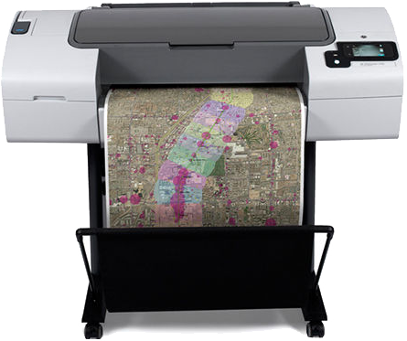

HP DesignJet printers for CAD/GIS
Print maps, technical drawings, and renders with precise line quality and crisp text – in color and black and white.
- HP DesignJet T120 Printer
- HP DesignJet T520 Printer series
- HP DesignJet T730 Printer
- HP DesignJet T795 Printer
- HP DesignJet T830 Multifunction Printer
- HP DesignJet T930 Printer series
- HP DesignJet T1530 Printer series
- HP DesignJet T2530 Multifunction Printer series
- HP DesignJet T3500 Production Multifunction Printer series
- HP DesignJet SD Pro Multifunction Printer
- HP DesignJet HD Pro Multifunction Printer
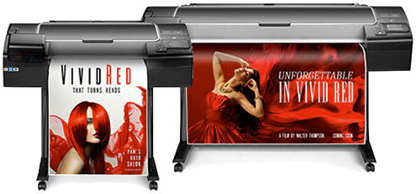

HP DesignJet high-impact graphics printers
Create eye-catching, high-quality applications—including POP signage, posters and banners—effortlessly and affordably.
- HP DesignJet Z2100 Photo Printer series
- HP DesignJet Z2600 PostScript® Printer
- HP DesignJet Z3200 Photo Printer series
- HP DesignJet Z5200 Photo Printer
- HP DesignJet Z5400 PostScript Printer
- HP DesignJet Z5600 PostScript® Printer
- HP DesignJet Z6200 Photo Production Printer
- HP DesignJet Z6600 Production Printer
- HP DesignJet Z6800 Photo Production Printer
- HP DesignJet HD Pro Multifunction Printer
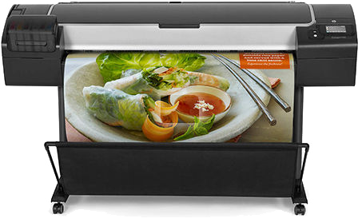

HP DesignJet large-format production printers
Manage your highest printing demands, from simple CAD drawings in B&W to complex color images, with speed and quality.
- HP DesignJet Z6200 Photo Production Printer
- HP DesignJet Z6600 Production Printer
- HP DesignJet Z6800 Photo Production Printer
- HP DesignJet T3500 Production Multifunction Printer series
- HP DesignJet T7200 Production Printer
- HP DesignJet SD Pro Multifunction Printer
- HP DesignJet HD Pro Multifunction Printer
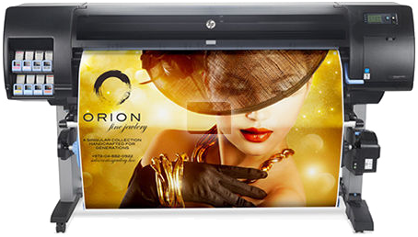

HP DesignJet professional photo-quality printers
Deliver impressive professional photo- and gallery-quality prints with the widest color gamut and superior gloss uniformity.
- HP DesignJet Z2100 Photo Printer series
- HP DesignJet Z3200 Photo Printer series
- HP DesignJet Z5200 Photo Printer
- HP DesignJet Z6200 Photo Production Printer
- HP DesignJet Z6800 Photo Production Printer
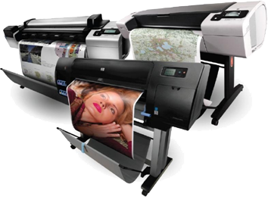

Designjet Large Format Printers

- HP Designjet 400 Printer series
- HP Designjet 500 Printer series
- HP Designjet 510 Printer series
- HP Designjet 5000 Printer series
- HP Designjet 5500 Printer series
- HP Designjet 800 Printer series
- HP Designjet T1100 MFP series
- HP Designjet T1100 Printer series
- HP Designjet T1120 HD
- HP Designjet T1120 HD Multifunction Printer series
- HP Designjet T1120 Printer series
- HP Designjet T1200 Printer series
- HP Designjet T610 Printer series
- HP Designjet T620 Printer series
- HP Designjet T770 Printer series
- HP Designjet Z3100 Photo Printer series
- HP Designjet Z6100 Printer series

HP 500 - 800 DesignJet Error Codes

- Error Code 86:01 – Worn Carriage belt (24″ Belt / 42″ Belt). Belt starts to breakup leaving belt dust inside printer and making clunking noise from motor with build up of rubber on gear.
- Error Code 86:01 – Dirty Encoder strip hard to clean replace. (24″ Encoder / 42″ Encoder)
- Error Code 11:11 – Trailing Cable badly connected or worn. (24″ Trailing Cbale / 42″ Trailing Cable)
- Error Code 21:10 – Service Station failure.
- Error Code 81:01 – Paper feed motor failure.
- Error Code 02:10, 02:13, 12:11 – Carriage Assembly failure.
- Error Code 03:10 – Power Supply failure.
- Error Code 05:10 – (Only applicable to HP DesignJet 800 Series) Formatter failure.
- Blue handle breaking (Pinch-Arm Mechanism)
- Some random errors can be caused by faulty printhead /ink cartridge. Take all consumables out, then switch printer back on.

HP Designjet Z6100 Error Codes

- Error 24:10, Ink broken bag error, if ink has leaked over Tube System pcb you need to replace Tube System as this can be result from 24:10. 42″ tube System – 60″ Tube System
- Error 86:01 same as 87:01 Encoder strip (42″ Encoder 60″ Encoder) getting dirty! Encoder Strip becomes unreadable after user cleaning to many times and needs replacing. Other issues from this error code Carriage Belt worn (42″ Belt 60″ Belt) and Carriage Lubrication Felt dry and dirty.
- Blank display due to CPU fan failure and printer switching off after short time.
- Ink vapors build up due to service station vent holes blocking up.
- Vacuum path holes blocked up due to ink in the holes causes reduction in holding media down.
- Media Blue Handle breaking causing handle to be loose and not releasing pinch rollers.
- Spindle (42″ Spindle 60″ Spindle) end breaking on edge causing judder on spindle plus media going out of line on long print runs.
- Roll housing right hand side tension spring breaking causing paper loading problems.
- Image quality issues: Run Image Quality Test to show which printhead is not 100%. Select the ink icon and then select Image Quality Maintenance > Printhead Diagnostics Image.
- Pinch roller assy: some of the rollers fall off then metal spring digs into feed roller.

HP Designjet 5000/5500 Error Codes

- Calibration failure at 30% or 70% line sensor failure. 5000 Line Sensor – 5500 Line Sensor
- Printer path 2! Carriage Belt worn. 42″ Belt – 60″ Belt
- Printhead failing after 40ml due to air in Tube System
- Belt Tensioner Roller broken
- Boot-up failure due to hard drive being corrupt
- Jetdirect card fail due to spike in network
- Blue End caps broken on spindle. Spindle 42″ – Spindle 60″
- Ink cartridge fail in one colour due to tube system issues
- Pinch roll assy: Some of the rollers fall off then metal spring digs into feed roller.
- Cutter roller worn or broken causing cutter not to cut media.

HP Designjet T/Z-Series Error Code
HP T610, T620, T770, T790, T1100, T1120, T1200, T1300, T2300, Z2100, Z3100 and Z3200 Designjet Printers 24" 44"
- Error Code 47:01 – Star Wheel bail arm was not moving up or down due to star wheel Motor
- Error Code 41:01 – Electrical fault or current limit in Media-Axis Motor due to paper jam or 47:01 Error code
- Error Code 03:10 – Noise coming from L/H side of printer with error – Need Power Supply.
- Error Code 86:01 – Encoder strip (24″ Encoder” 44″ Encoder) dirty need cleaning or replacing.
- Error Code 86:01 – Scan-Axis Motor failure (likely due to obstacles in the scan axis or electrical fault). Carriage belt (24″ Belt 44″ Belt) worn or Scan Axis motor faulty.
- Error Code 08:11 – No communication between the Front Panel and the Main PCA.
- Not Cutting – Cutter needs cleaning.
- Error Code 21:13 – Fail moving Service Station
- Error Code 11:01 – Trailing cable issues (24″ Trailing Cable 44″ Trailing Cable)

We Carry Fully Refurbished DesignJet Plotter For Sale

Los Angeles County – CA HP DesignJet Plotter Wide Format Repair Services
Agoura Hills | Diamond Bar | Altadena | Rolling Hills Estates
Alhambra | Downey | Lawndale | Rosemead
Arcadia | Duarte | Lomita | San Dimas
Artesia | El Monte | Long Beach | San Fernando
Avalon | El Segundo | Los Angeles | San Gabriel
Azusa | Gardena | Lynwood | San Marino
Baldwin Park | Glendale | Malibu | Santa Clarita
Bell | Glendora | Manhattan Beach | Santa Fe Springs
Bell Gardens | Hawaiian Gardens | Maywood | Santa Monica
Bellflower | Hawthorne | Monrovia | Sierra Madre
Beverly Hills | Hermosa Beach | Montebello | Signal Hill
Bradbury | Hidden Hills | Monterey Park | South El Monte
Burbank | Huntington Park | Norwalk | South Gate
Calabasas | City of Industry | Marina Del Rey | South Pasadena
Carson | Inglewood | Palos Verdes Estates | Temple City
Cerritos | Irwindale | Paramount | Torrance
Claremont | La Canada Flintridge | Pasadena | Vernon
City of Commerce | La Habra Heights | Pico Rivera | Walnut
Compton | La Mirada | Pomona | West Covina
Covina | La Puente | Rancho Palos Verdes | West Hollywood
Cudahy | La Verne | Redondo Beach | Westlake Village
Culver City | Lakewood | Rolling Hills | Whittier

Orange County – CA HP DesignJet Plotter Wide Format Repair Services
Aliso Viejo | Anaheim | Brea | Buena Park
Costa Mesa | Cypress | Dana Point | Fountain Valley
Fullerton | Garden Grove | Huntington Beach | Irvine
Laguna Beach | Laguna Hills | Laguna Niguel | Laguna Woods
La Habra | Lake Forest | La Palma | Los Alamitos
Mission Viejo | Newport Beach | Orange | Placentia
Rancho Santa Margarita | San Clemente | San Juan Capistrano | Santa Ana
Seal Beach | Stanton | Tustin | Villa Park
Westminster | Yorba Linda

Riverside County-Ca HP DesignJet Plotter Wide Format Repair Services
Corona | Corona | Eastvale | Jurupa Valley
Lake Elsinore | La Quinta | Moreno Valley | Murrieta
Norco | Palm Desert | Palm Springs | Riverside

San Bernardino County – CA HP DesignJet Plotter Wide Format Repair Services
Chino | Chino Hills | Colton | Fontana
Grand Terrace | Loma Linda | Montclair | Ontario
Rancho Cucamonga | Redlands | Rialto | San Bernardino
Twenty nine Palms | Upland

Ventura County - CA HP DesignJet Plotter Wide Format Repair Services
Camarillo | Fillmore | Moorpark | Oxnard
Simi Valley | Thousand Oaks | Ventura

